* Git hub is used to **keep and manage our source code**.

There are many versions but git is a popular version.

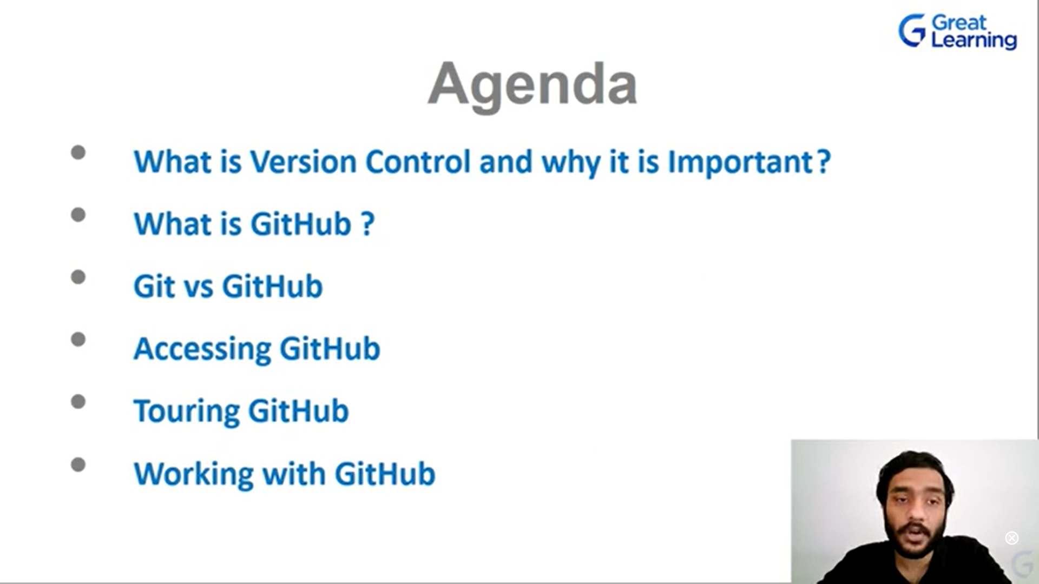

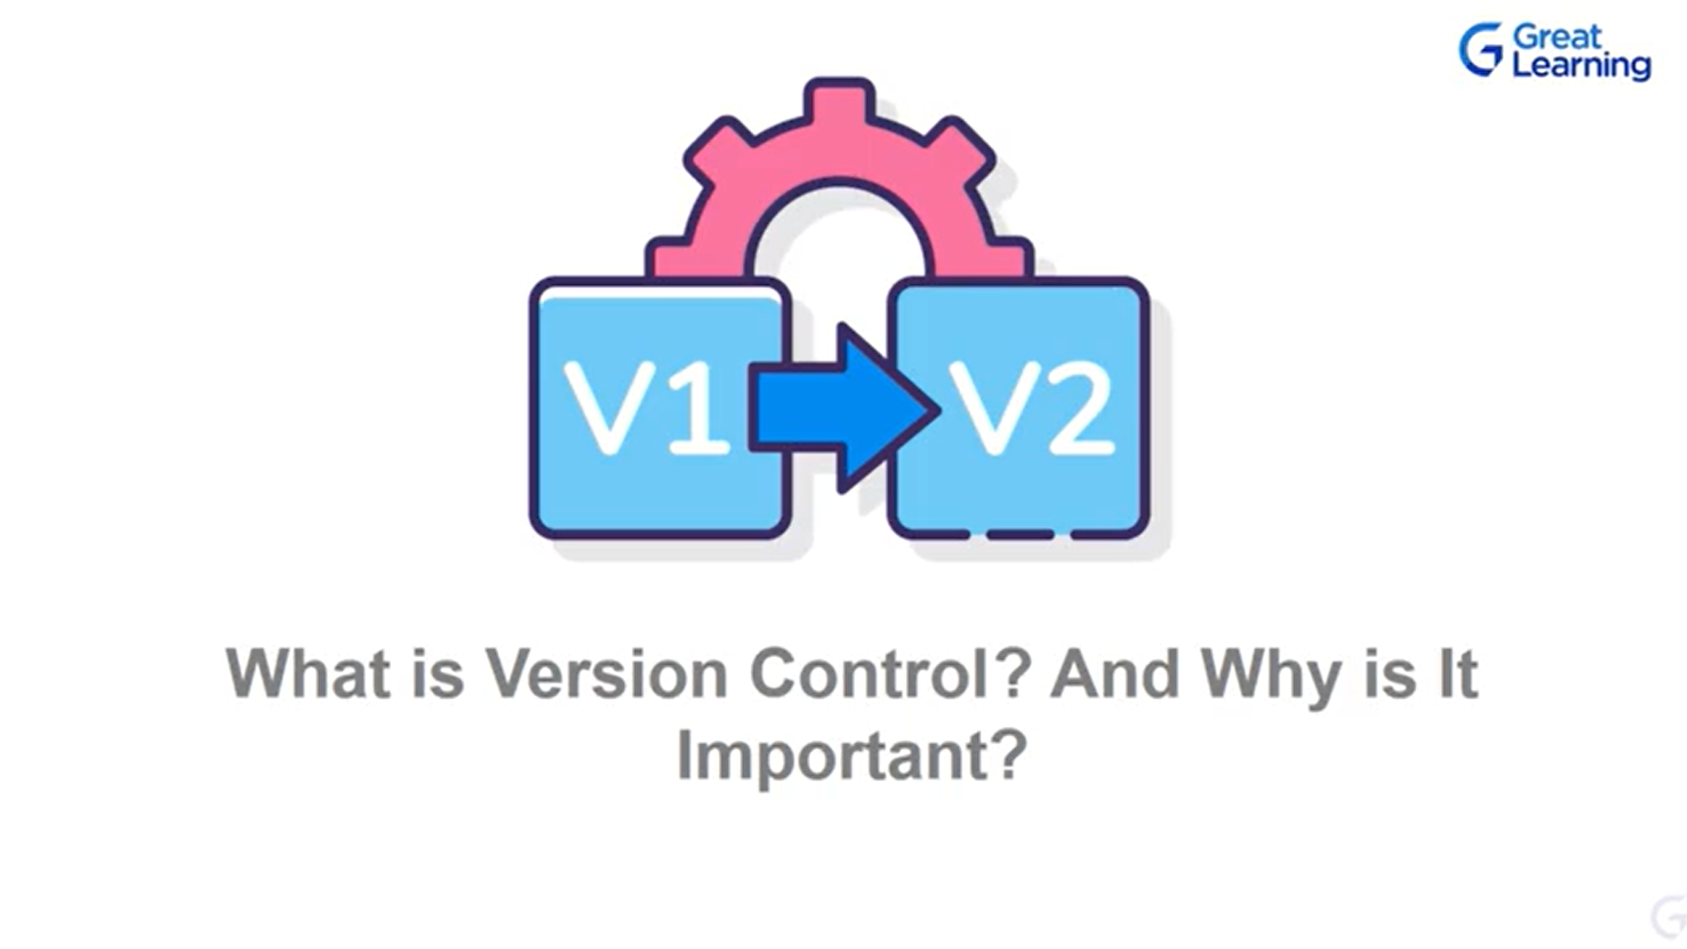



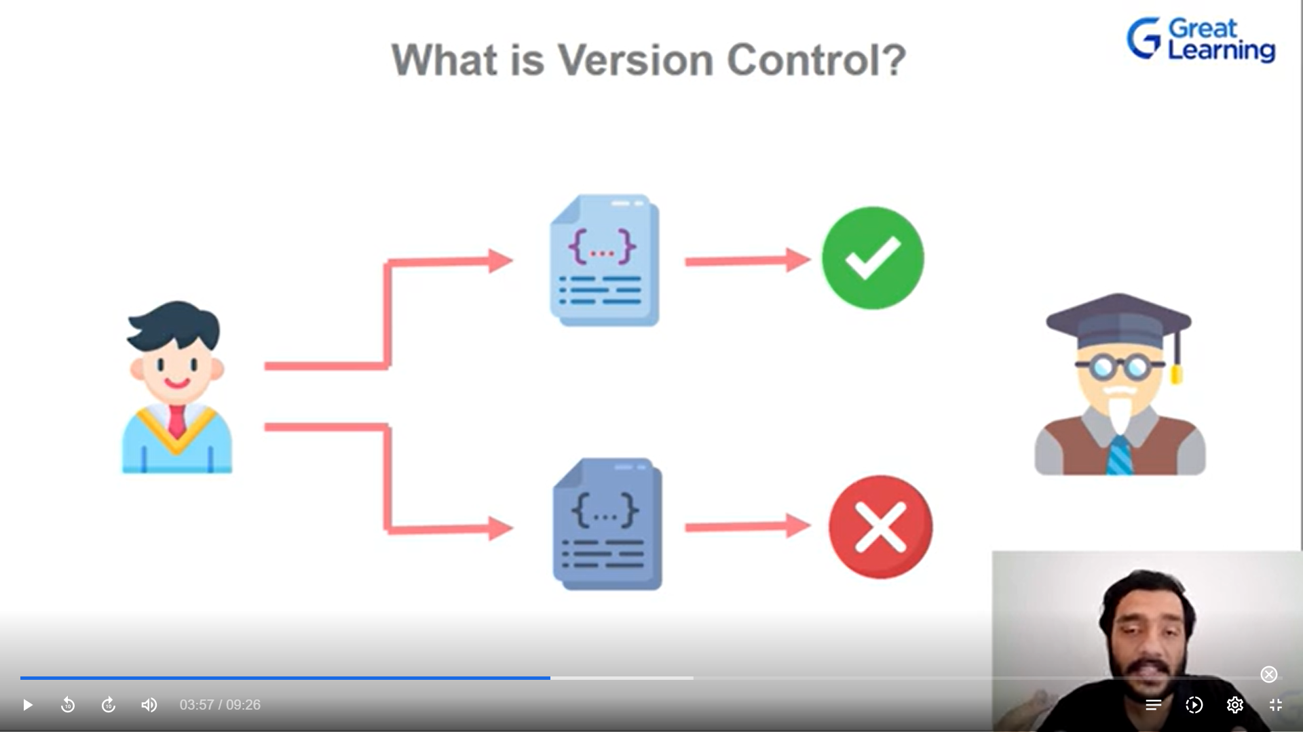



If the code ran successfully then he took backup. Then he decides to do change in the code and got everything wrong.

So he can take again the **backup code**

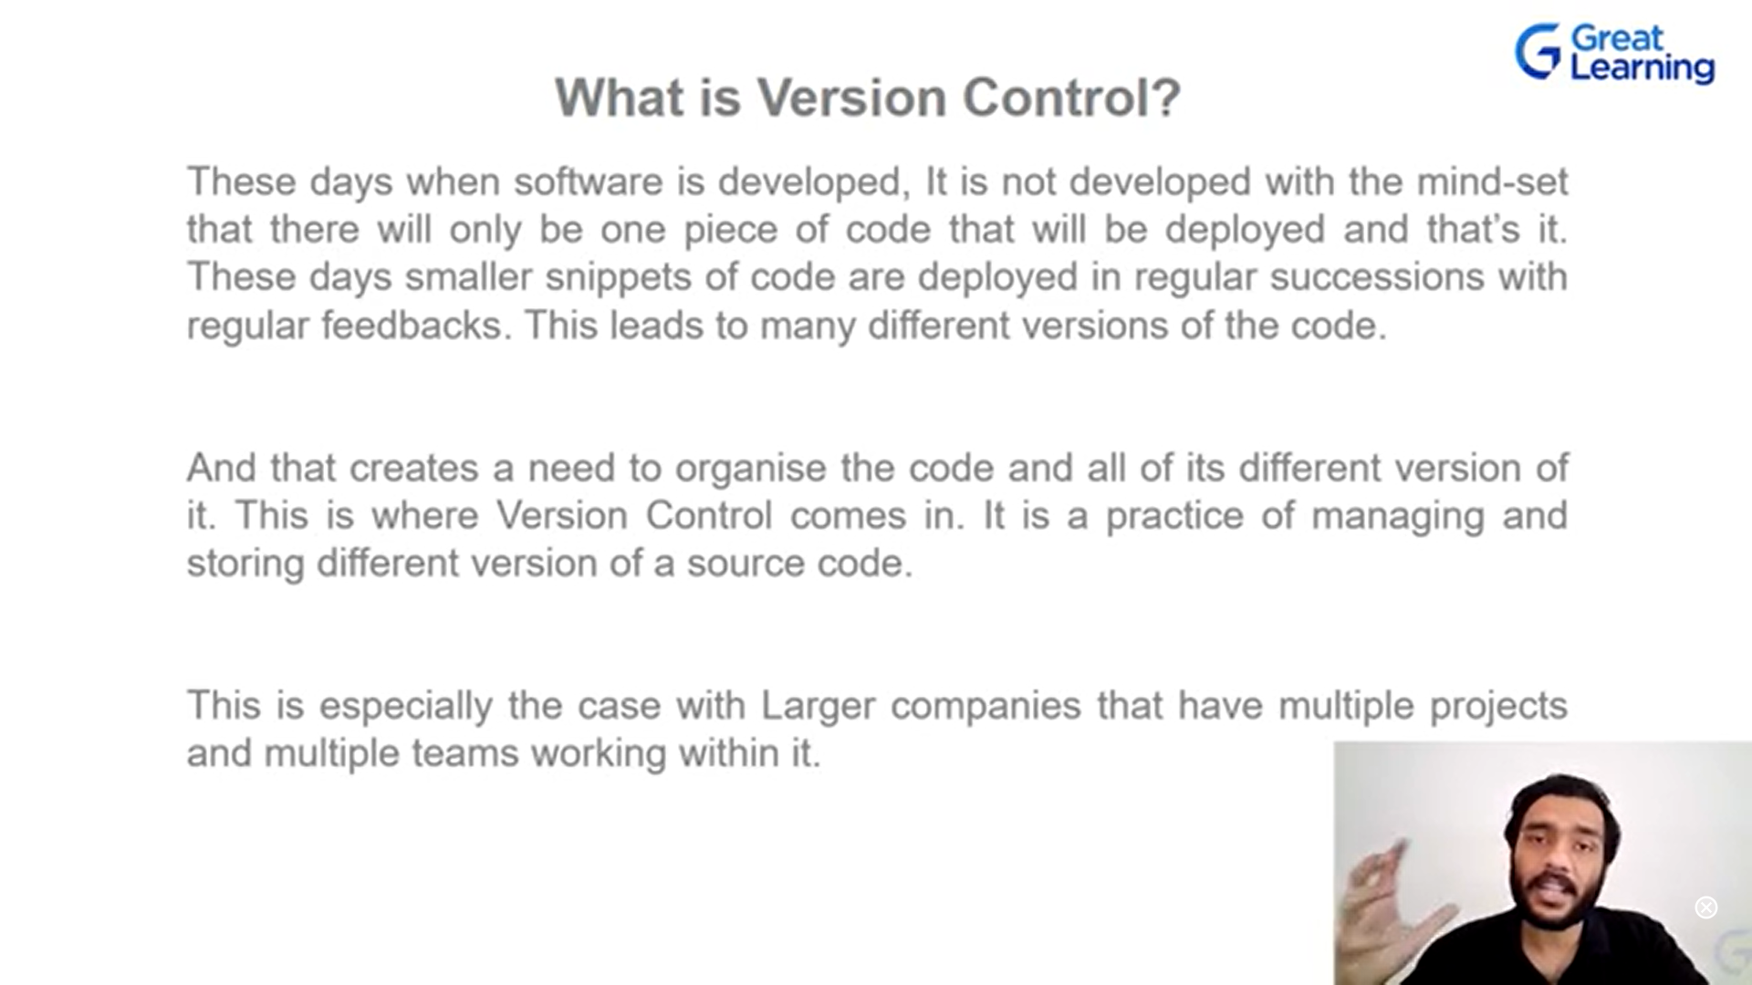

Version control helps us to mange all the codes.

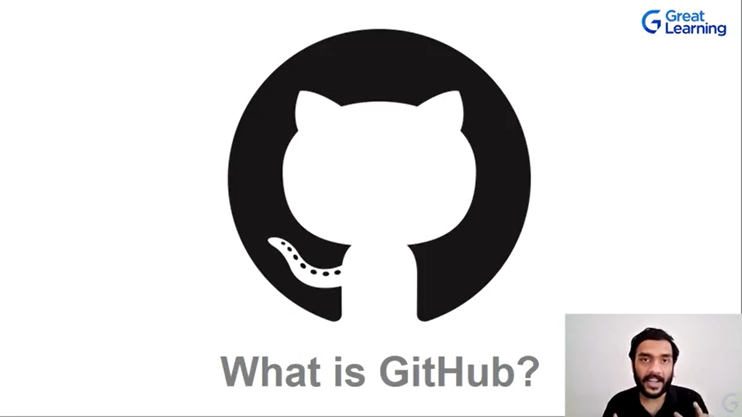

**Popular tools used is git and github. (they work togther)**

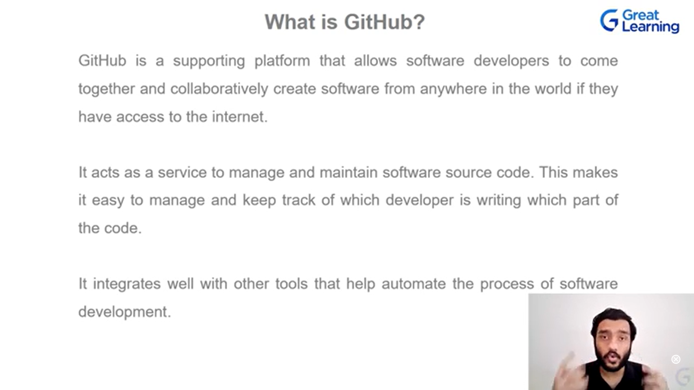

**github is a place where the differebt versions of code is managed , keep track of it.**

**Github is cloud based service.**

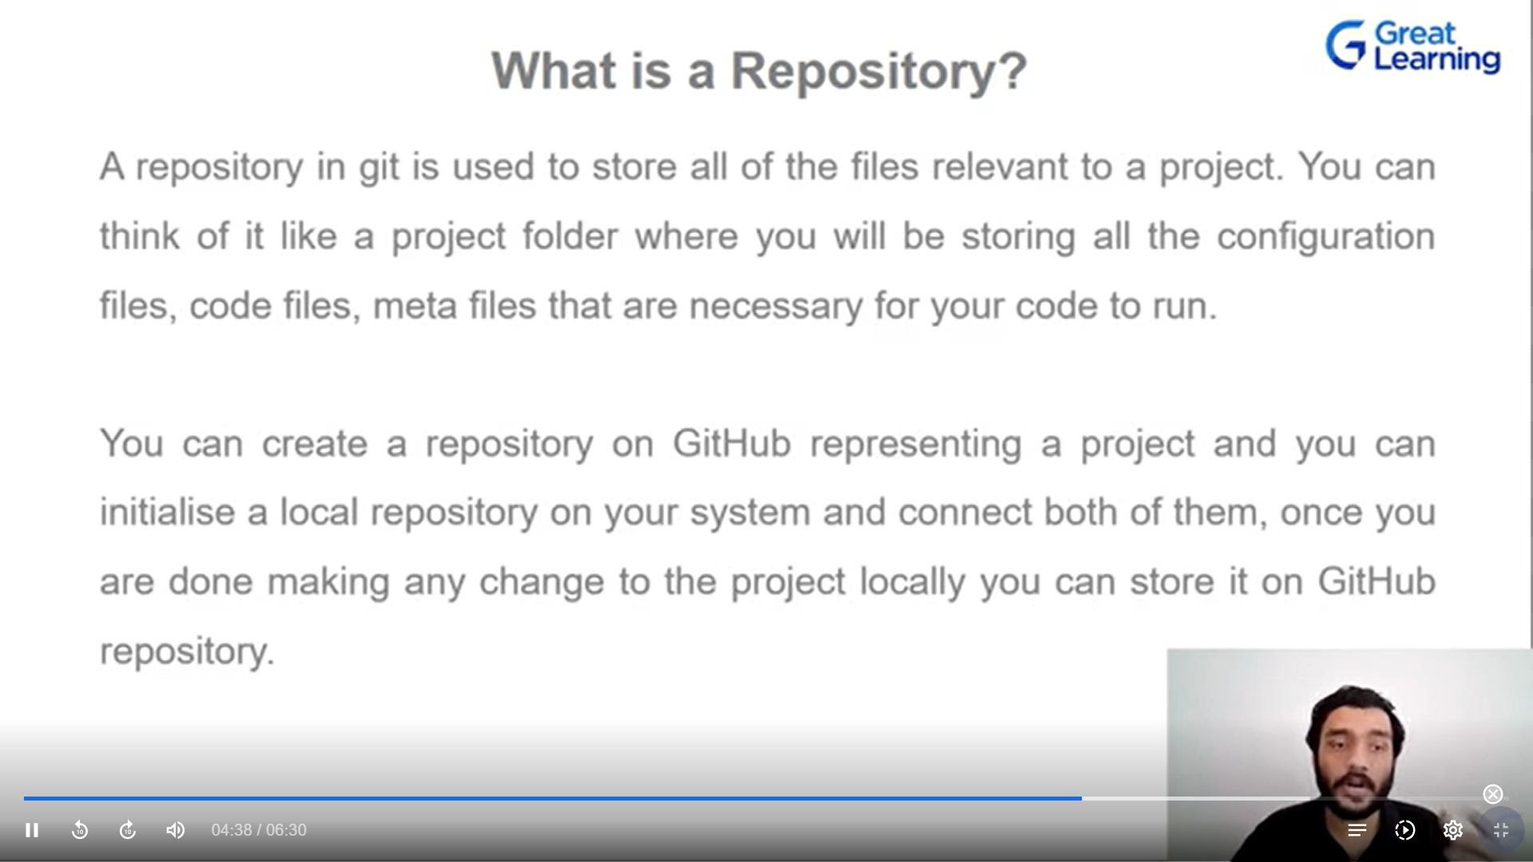

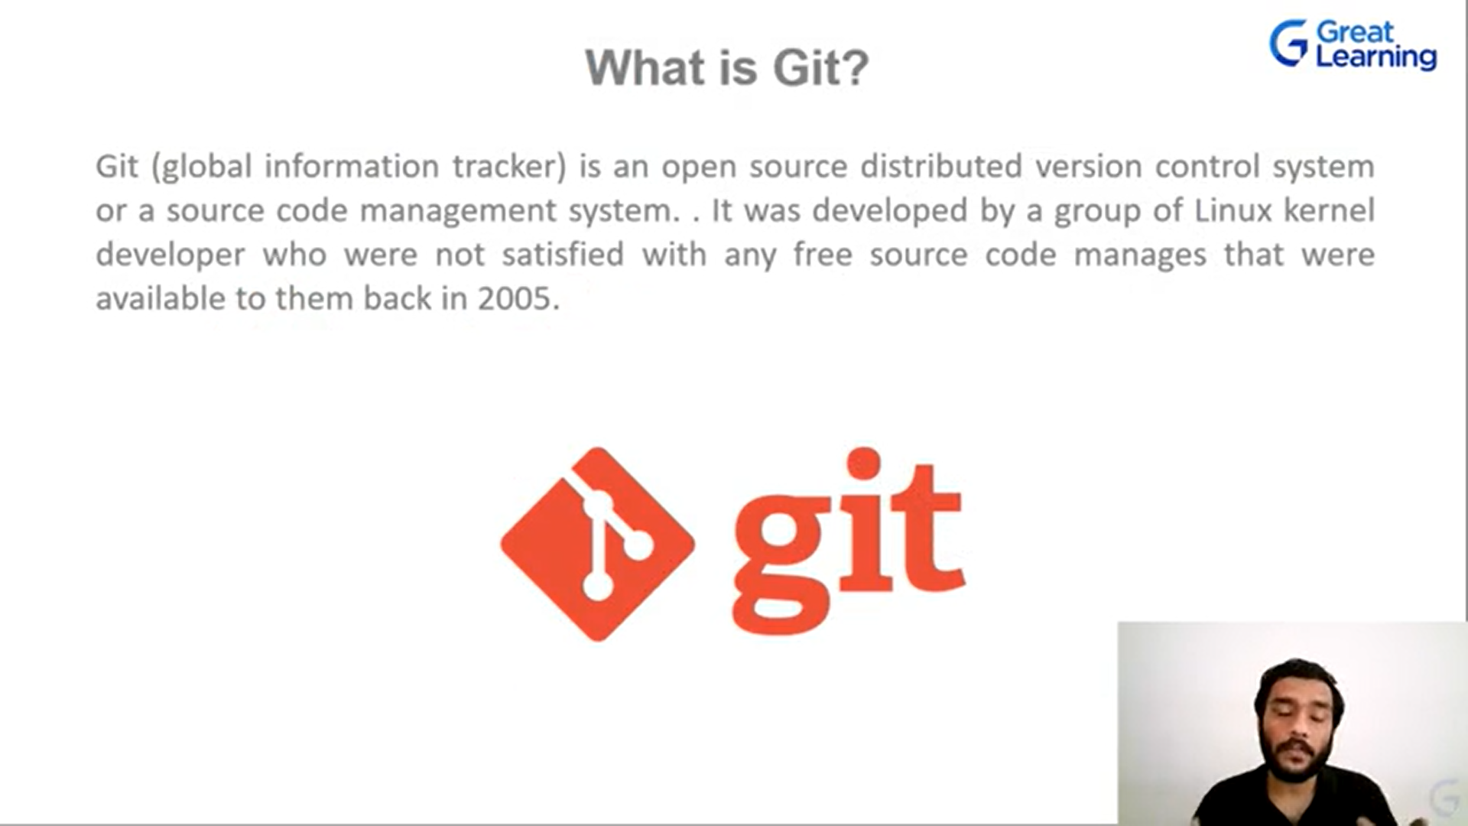

**Our project is stored in github. If I modify the source who will inform to github (its git) changes done 1 time , changes done 2 time like this.**

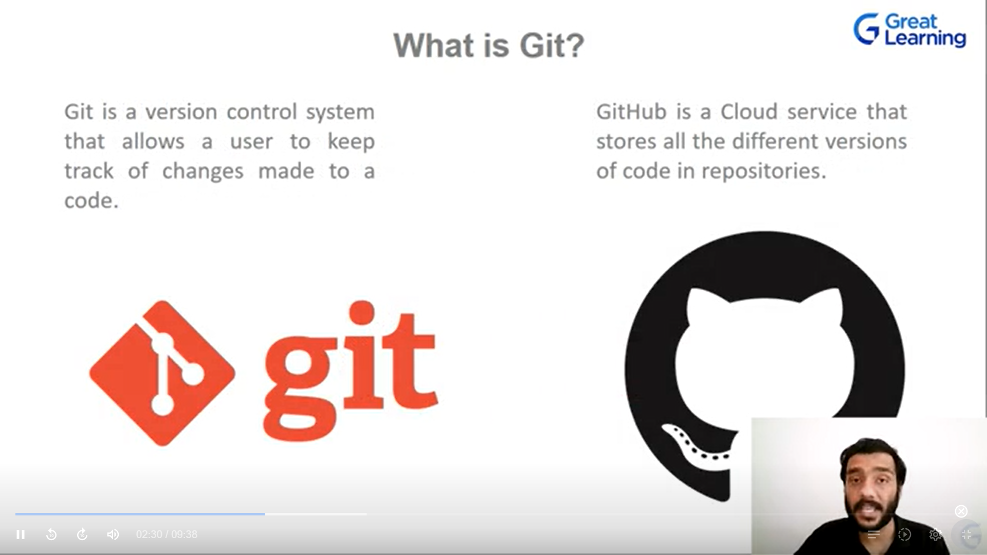

**Git works locally github uses online to store**

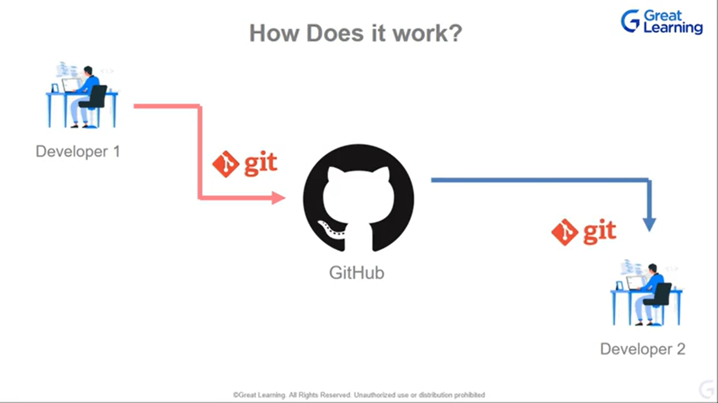



* **Developer 1 do the code and uses git to keep track of it. If he satisfied then he push into github.**
* **Developer 2 takes the code and download the code in his system.**

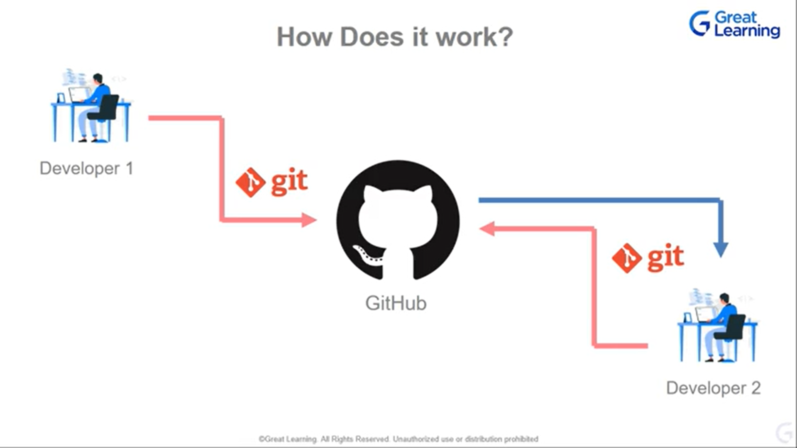



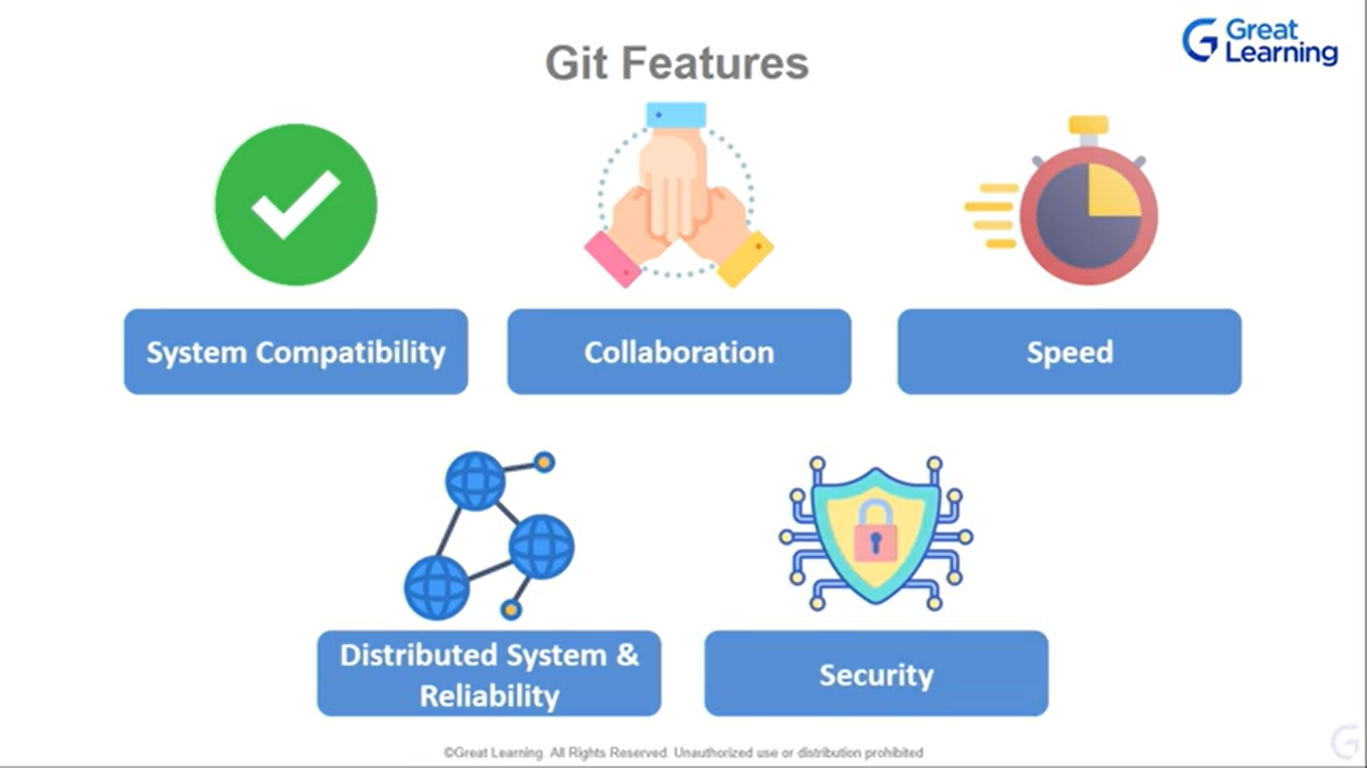

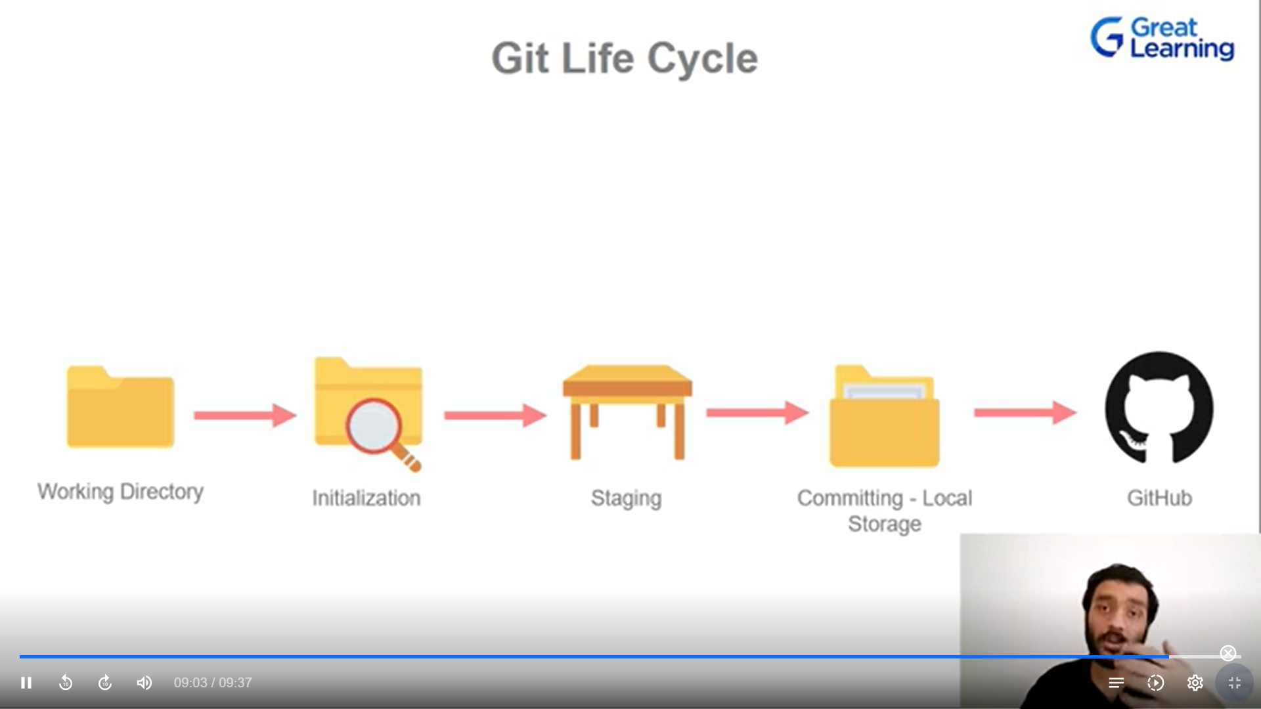

**Initializing – that im telling git that to recognize as a local repository**

**Staging – telling git that I have these files keep the track of it.**

**Commiting – once I satisfied on this cycle, I can save in local**

**Then push the saved piece of code to github.**

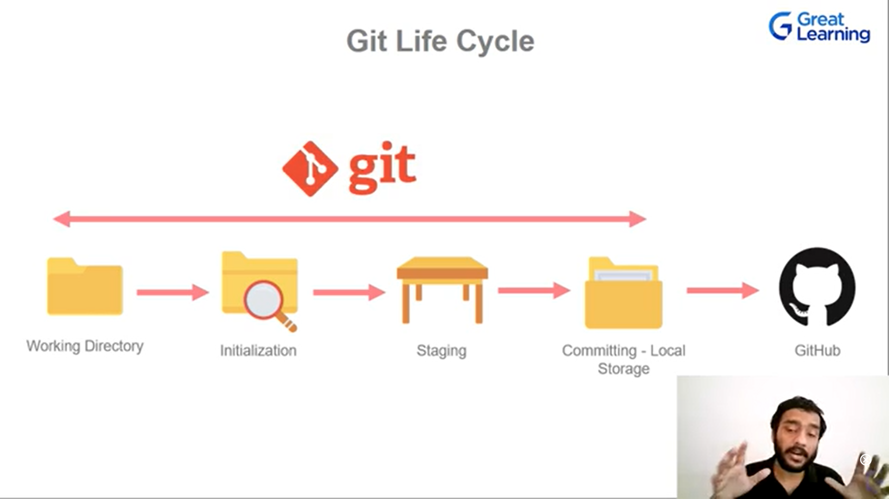



**Forking – copying my repository by someone for their use.**

**Pull request – when pull request is raised, a person who has authority, will read to the pull request that what have u suggested is good only then he will approve it.**

**Marketplace – to get extra plugins needed**

**Explore - like twitter page**

**Branches - eg. We take a software and create branches of it to work by multiple people, we can create branches and attach to main branch**

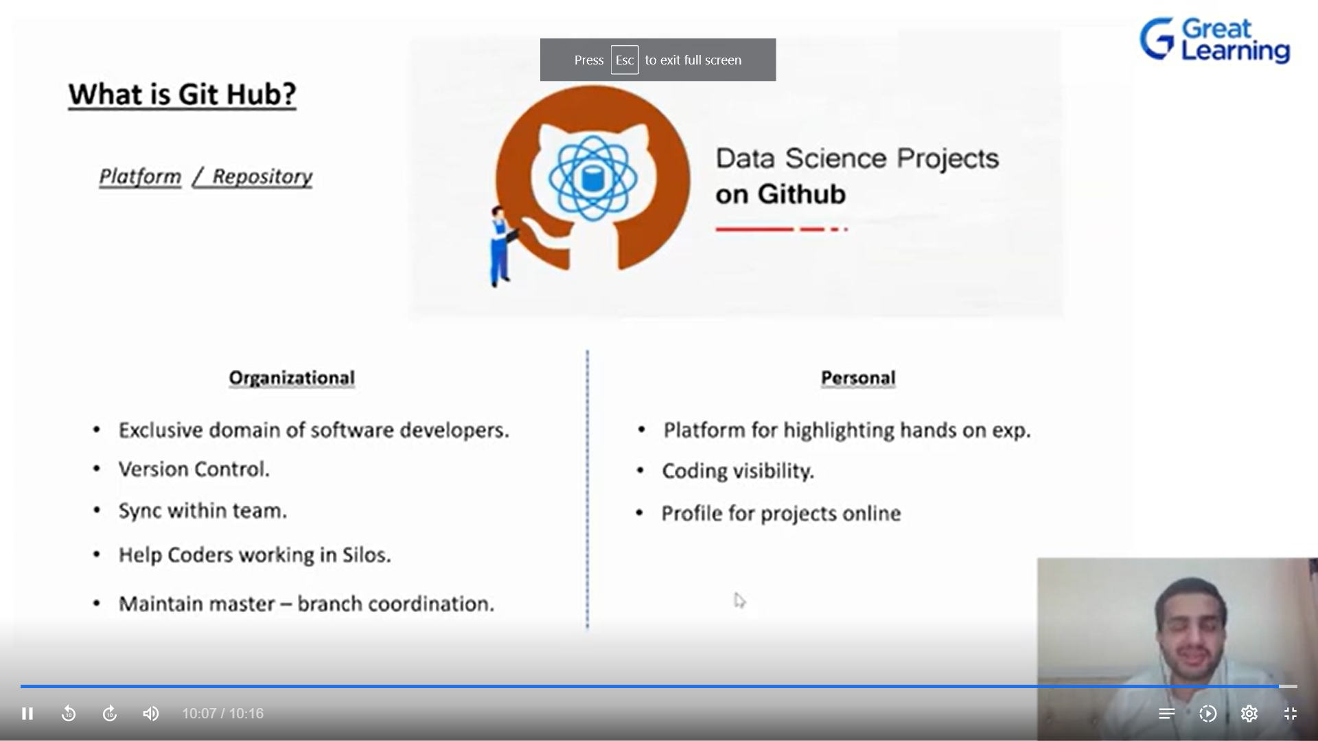

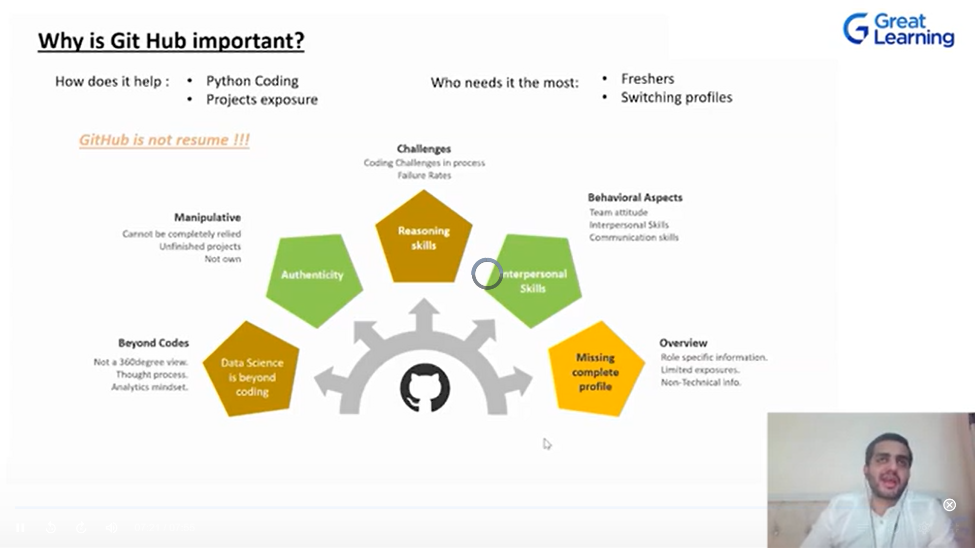



**Q&A:**



**No, its language independent**

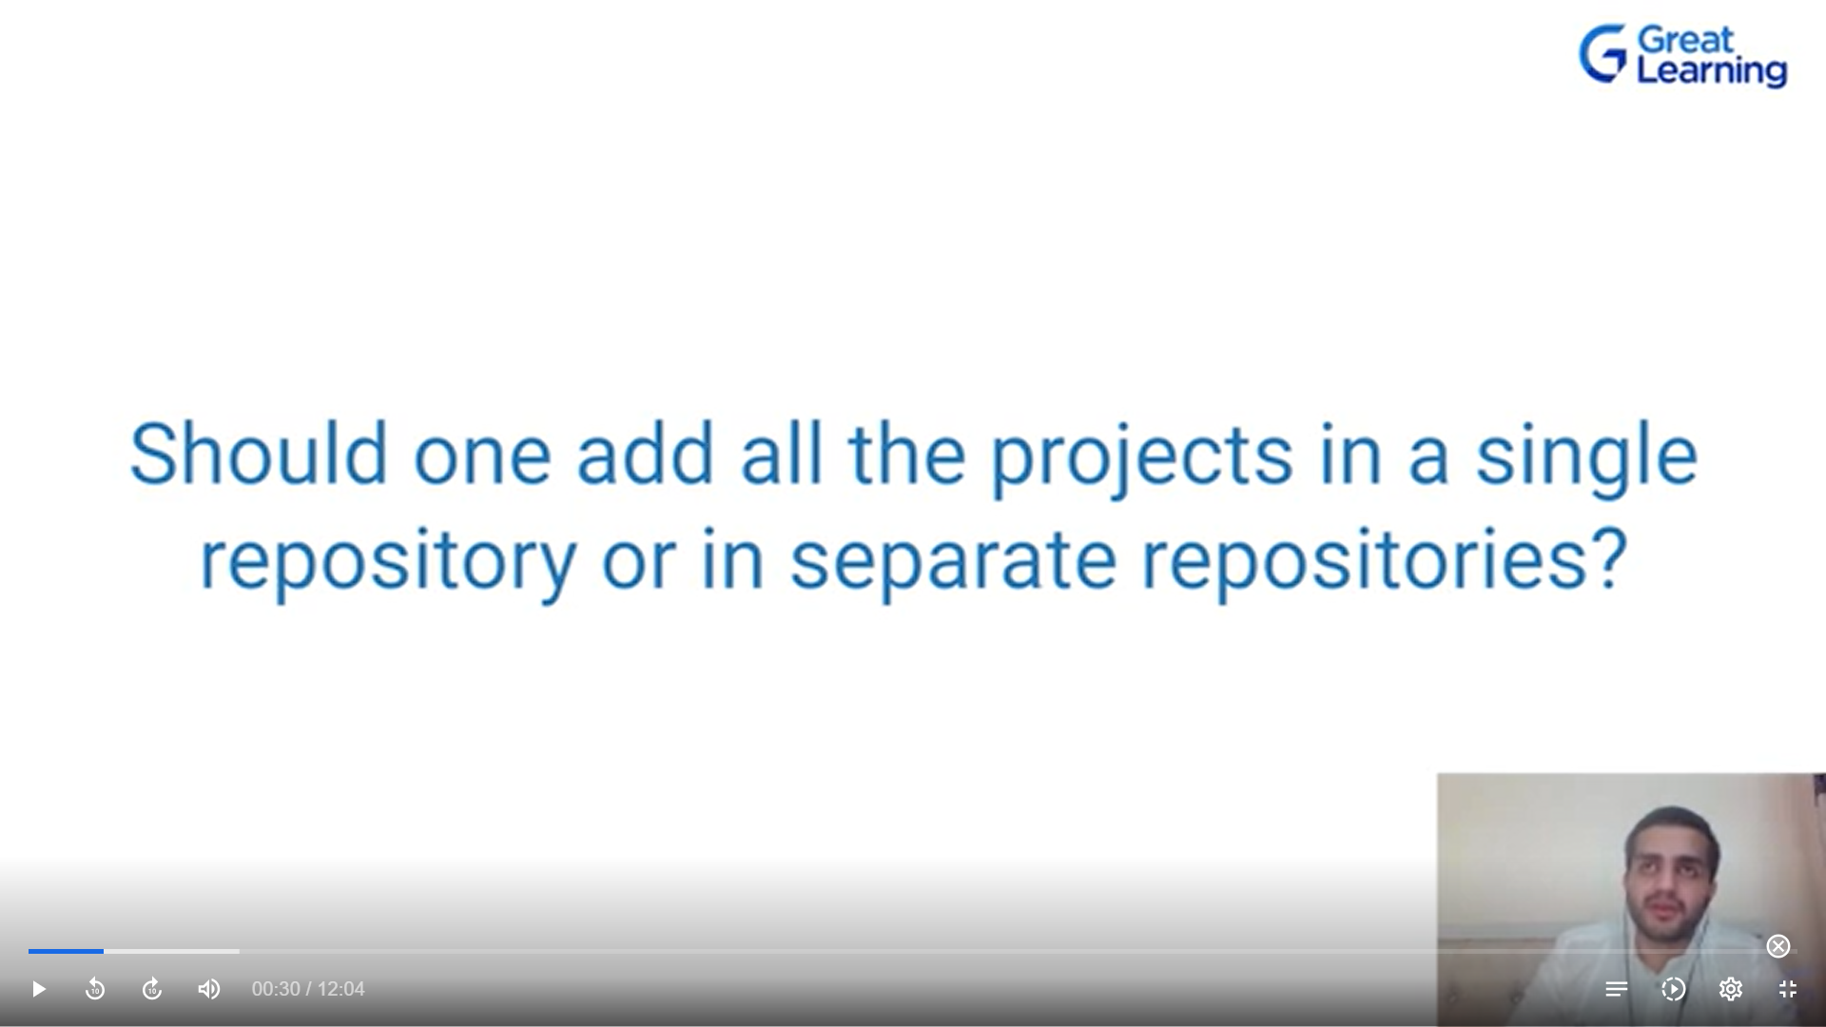

**No it Is good to manintain in unique repository (fr structured way)**